“DATA EXFILTRATION DETECTION THROUGH EMAIL-BASED INSIDER THREATS”
A Report submitted
in partial fulfilment for the Degree of

Masters of Science
IN
Cyber Security

Submitted By
Disha Sharma
(240103002014)

Under the Supervision of
Mr. Dharmesh Dave
(Assistant Professor)


Submitted to

SCHOOL OF CYBER SECURITY & DIGITAL FORENSICS,
NATIONAL FORENSIC SCIENCES UNIVERSITY
GANDHINAGAR – 382007, GUJARAT, INDIA.
MAY, 2025

DECLARATION
I DISHA SHARMA having Enrollment Number 240103002014 hereby declare that

a. The work contained in the dissertation report entitled “DATA EXFILTRATION DETECTION THROUGH EMAIL-BASED INSIDER THREATS” is being submitted in partial fulfilment for the award of the degree of Msc. Cyber Security to School of Cyber Security & Digital Forensics is an authentic record of my own work done under the supervision of Mr. Dharmesh Dave.
b. The work has not been submitted to any other Institute/ School / University for any degree or diploma.
c. I have conformed to the norms and guidelines given in the Ethical Code of Conduct of the School.
d. Whenever I have used materials (data, theoretical analysis, and text) from other sources, I have given due credit to them by citing them in the text of the dissertation and giving their details in the references.
e. Whenever I have quoted written materials from other sources and due credit is given to the sources by citing them.
f. From the plagiarism test, it is found that the similarity index of whole dissertation is less than 10 % as per the university guidelines.

Date:
Place:

Signature of Student

__________________
Signature & Date
Supervisor

CERTIFICATE
This is to certify that the work contained in the dissertation entitled “DATA EXFILTRATION DETECTION THROUGH EMAIL-BASED INSIDER THREATS”, submitted by Disha Sharma (Enroll. No.: 240103002014) in partial fulfilment of the requirement for the award of the degree of Msc. Cyber Security to the National Forensic Sciences University, Gandhinagar, Gujarat is a record of bonafide work carried out by him/her under the direct supervision and guidance of Mr. Dharmesh Dave.
Date:
Place:

Supervised By:
____________________ _____________
(Name & sign of the Supervisor 1) (Name & sign of the Supervisor 2, if any)
Designation,
School of Cyber Security and Digital Forensics,
National Forensic Sciences University,
Gandhinagar, India, 382421

_______________________________
Dean, School of Cyber Security and Digital Forensics,
National Forensic Sciences University,
Gandhinagar, India, 382421

ACKNOWLEDGEMENTS

I would like to express my sincere gratitude and deepest appreciation to Mr. Dharmesh Dave, my esteemed mentor, for his exceptional guidance and unwavering support during the course of this dissertation.
His invaluable insights and meticulous attention to detail have been instrumental in shaping and refining this research project. His exceptional guidance, profound expertise and constructive feedback have been the stepping stones of my intellectual and academic journey and his dedication has been commendable throughout.
Mr. Dharmesh Dave’s mentorship has not only enahnced my understanding of the subject matter but also instilled in me a deep sense of discipline and scholarly rigour. His unwavering commitment to excellence has served as a constant source of inspiration, urging me to push the boundaries of knowledge in the field of Threat Intelligence and Intrusion Detection.

To Mr. Dharmesh Dave and all my lab mates who have contributed to this dissertation in various capacities, I offer my profound gratitude. Your exceptional guidance, support and expertise have not only impressed me but also served as the cornerstone of this research endeavour.

With Sincere Regards,

Disha Sharma
Msc. Cyber Security

ABSTRACT
This dissertation introduces the development and design of a real-time detection tool targeting the detection of data exfiltration attempts through email-based insider threats in a small to mid-sized organizational environment. The key aim is to detect accidental as well as malicious insider behavior—such as phishing email interactions, misdirected emails, and unauthorized transmission of confidential information—through a mix of static rules, behavioral detection, and content-aware methods.

The tool connects to the Gmail API to track incoming and outgoing email activity, providing support for real-time alerting through push notifications. Confidential corporate files are labeled by sensitivity level, and a two-layered detection system is put in place using fuzzy hashing and NLP-content-based verification to detect attempts at circumventing detection through file alteration or coded messaging. A built-in alerting system classifies threats by severity, with color-coded CLI logs and optional notifications, providing greater visibility to security teams.

The dissertation is organized into several phases, starting with the identification of the problem space and the setting of the objectives; describing the system architecture and major components; describing the detection methods, rule-based and anomaly detection models; describing the implementation process and integration with Gmail; testing the performance of the system using simulated insider scenarios. The last phase concludes the results and provides suggestions for future improvement, including SIEM integration and adaptive learning mechanisms.

The results verify the tool's success in identifying varied types of data exfiltration via email and its usability in a 15–20 employee setup. The project accomplishes the fundamental aim of providing improved insider threat visibility with low false positives and low operational overhead.

Keywords: Real-time detection, Insider behaviour, Gmail API, CLI logs, Rule-based, SIEM Integration, Data Exfiltration, False Positives, Severity, Built-in alerting system

LIST OF ABBREVIATIONS

Abbreviations should be alphabetically written

Abbreviation | Description
API | Application Programming Interface
CLI | Command Line Interface
SIEM | Security Information & Event Management
IDS | Intrusion Detection System
IBM | International Business Machines Corporation
BYOD | Bring Your Own Device
ZIP | Zipped
RBAC | Role Based Access Control
API | Application Programming Interface
CLI | Command Line Interface
API | Application Programming Interface
CLI | Command Line Interface
API | Application Programming Interface
CLI | Command Line Interface

LIST OF TABLES

Table 1 Comparative Analysis with Existing Tools 5

LIST OF FIGURES

Figure 1 NFSU Logo as Example 8

Add Table Caption From References > Insert Caption > Add Table / Figure Caption

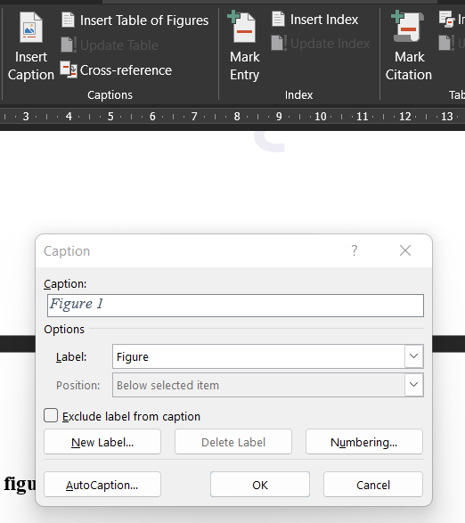

LIST OF SYMBOLS
**Symbols should be alphabetically written

TABLE OF CONTENTS
1. | Introduction………………………………………………………………………
 | 1.1 Motivation…………………………………………………………………… | 1
 | 1.2 Scope of the Project………………………………………………………… | 2
 | 1.3 Organization of Report……………………………………………………… | 3
2. | Theoretical Background & Literature Survey…………………………………
 | 2.1 Comparative Analysis of Existing Schemes…………………………………
 | 2.2 Research Findings……………………………………………………………
3. | The Proposed Model and Implementation Methodology…………………….
 | 3.1 The Problem Statement………………………………………………………
 | 3.2 The System Model OR Sketch of the Framework…………………………
 | 3.3 Methodology ………………………………………………………………….
4. | Theoretical & Empirical Result Analysis……………………………………….
4.1 Experimental Setup ………………………………………………….…….
(Discuss Dataset, Tools Technology to be used)
 | 4.2 Evaluation Metrics …………………………………………………………..
 | 4.3 Test Application/ Scenario…………………………………………………..
4.4 Theoretical analysis ………………………………………………………….
(Computation, Communication overhead, resource utilization etc.)
4.4 Implementation Result Analysis…………………………………………….
(Results in graph or Tabular form are expected, do not show Report generated by tool)
 | 4.5 Comparative Analysis………………………………………………………..
5. | Conclusion………………………………………………………………………..
6. | Future Work and Plan…………………………………………………………..
 | 6.1 Progress Report Gantt Schedule Chart……………………………………..
 | Our Publications OR Papers submitted for Publication
 | Enumerative Bibliography

Our Publications OR Papers submitted for Publication (/*write as appropriate if any */)
/* specify your publications in proper format if paper already published; otherwise specify the name of the conference/journal, its location and when submitted. Note this is only an entry in the Table of Contents, the actual details are to be written at the end of the report after the chapter 6 */

Ennumerative Bibliography………………………………………………
/* Bibliography should be strictly UNIFORM and in IEEE format */
/* please look up https://scholar.google.com/ for further information OR ASK YOUR SUPERVISOR */

- INTRODUCTION

  - Motivation
The past few years have seen a surge in the number of cyber attacks and cyber threats, globally. Of these legitimate and accounted threats, 83% of organizations reported atleast one insider threat in 2024 according to a study conducted by IBM. An even more surprising fact is that insider threat based attacks saw an increase of about five times than those accounted in 2023. While these threats are on a rise, it is important for organizations to address the risks posed by them in the digital ecosystem while putting into practice effective threat management strategies to address them.

Several studies were conducted to identify the root causes of insider threat based attacks and the following four reasons were prominent in facilitating insider threat attacks :

A) Complicated IT environments – Many organizations facilitate work-from-home environments and BYOD facilities even more after the COVID pandemic. This has increased the potential attack surface of organizations and provided greater access to confidential attachments of the organizations on emplyees’ remote devices.

B) Inadequate Security Measures – Several small and medium scaled organizations are not updated with latest security measuers and do not keep devices patched in accordance with recent security vulnerabilities. This proves to be a great risk for the organizations in the long run.

C) Lack of Employee Training and Awareness – Emplyees of the organization are not made familiar with acceptable use policies and user awarness protocols during their initiation that makes them vulnerable to external threat actors such as phishing emails.

D) Weak Enforcement Policies - Although 93% of respondents in the report said that strict visibility and control was an important factor for them, only 36% actually had an effective solution in place for unified visibility and access control.

According to Teramind Inc. about 67% of malicious insiders are likely to email sensitive data to outside parties leading to data exfiltration and major incident costs for the organizations. There could be several motives for insiders to facilitate such attacks, for instance – money, disgruntling experiences, revenge or even accidental emailing.

There are tools in the market to detect precursors and indicators regarding potential data exfiltration attacks, but some of them do not acount for false positives heavily while others are not able to classify the intention of the employee as malicious or accidental.

Thus, in developing this research project, my aim was to detect indicators of compromise for a data exfiltration attack through insiders of the organization via email communications and classify the attack intention as “malicious” or “accidental”.

  - Scope of the Project
The following are the objectives that the project aims to cover :

A) Phishing Detection – To detect phishing attempts either from senders external to the organization or within the organization and to flag them with a relevant severity level and intention classification. To also detect spoofed emails and hyperlink attachments by examining the body of email messages using pre-defined phishing keywords. To also flag repeated phishing attempts from insiders or outsiders.

B) Confidential Communication – To detect emails containing confidential keywords being sent to external receivers not a part of the organization and to flag these based on severity levels, intention classification and repeated attempts.

C) Confidential Attachments – To sign confidential files and detect emails containing these confidentional attachments addressed to employees within the organization not having access to them or external unauthorized entities. To flag these alerts based on severity levels, intention classification and repeated attempts.

D) ZIP Attachments – To flag emails containing compressed ZIP files and suspicous emails and to extract the contents and hash of the respective compressed file structure.

E) Normal Communication – To ensure that normal email communication between employees along with normal attachments are not flagged as suspicious emails to achieve the aim of reducing false positives.

F) User History – To set up a mechanism to record transactions carried out and processed by eah user of the organizations and add associated flags incase alerts are generated for the respective user to indicate the organization if a potential data exfiltration attempt occurs.

G) RBAC – To implement role based access control within the organization to ensure that confidential files are accessed by users of particular roles assigned to them, whereas normal users/employees are not granted the same priviledges.
H) Logging – To effectively log all threat alerts in a color-coded format acording to severity levels. To display the contents of confidential attachments if found. To remove redundant logs and process them according to timestamps.

I) Customizable Rule Set – To develop rule based intrusion detection system that can be customized according to the needs and preferences of the organization.

The scope of the project is carefully designed to address the most critical aspects of the identified problem domain while maintaing feasibility and accuracy of responses.

It is equally important to acknowledge the aspects outside the current scope of this project.
While the tool can successfully detect and classify the alert to a potential data exfiltration attempt, it does not deploy measures to prevent similar attacks or threats. To analyze the logs generated by the tool, an effective approach would be to enable a log parser. The tool does not make use of macro parsing for email content and attachments and thus generates alerts for a selected few attachments.

  - Organization of the Report
This report details the research, design, implementation, and evaluation of the "Email-Based Data Exfiltration through Insider Threat” tool. The subsequent chapters are organized as follows:
- Chapter 2: Theoretical Background & Literature Survey: Provides context by discussing relevant background concepts, reviewing existing insider threat solutions (traditional, specific, academic), highlighting their limitations in the email-based context, and identifying the research gap addressed by this project.
- Chapter 3: The Proposed Model and Implementation Methodology: Presents the detailed architecture of the tool, including its customized rule-set and unique features. It also describes the specific tools, techniques, rule types, and optimization strategies employed in its implementation.
- Chapter 4: Theoretical & Empirical Result Analysis: Describes the experimental setup, defines the evaluation metrics used to assess performance and accuracy, outlines the test scenarios, provides a theoretical analysis of expected behaviour, presents hypothetical empirical results, and compares these projected results against existing solutions.
- Chapter 5: Conclusion: Summarizes the entire project, highlighting the key findings, contributions, and the overall significance of the research project.
- Chapter 6: Future Work and Plan: Discusses potential future enhancements, extensions, and research directions stemming from this work, and includes a placeholder for the project schedule.
- References: Lists the bibliographic references cited throughout the report.

- THEORETICAL BACKGROUND & LITERATURE SURVEY
  - Comparative Analysis of Existing Schemes
Intrusion Detection Systems (IDS) play a crucial role in detecting and preventing security breaches within an organization. Several IDS tools are available, each offering unique strengths tailored to different threat models. This section provides a literature survey of prominent IDS tools, focusing on their methodologies, strengths, and limitations. Emphasis is placed on Snort, OSSEC, and Security Onion, widely used in academic and enterprise environments.

Feature | Snort | OSSEC | Security Onion
Detection Type | Signature-based | Log-based + Rule-based | Hybrid (Signature, Anomaly, Log)
Real-time Monitoring | Yes | Yes | Yes
Alerting Mechanism | Real-time alerts via syslog/snmp | Email, Syslog, Custom Scripts | GUI alerts, ELK Stack integration
Type of Data Monitored | Network packets | System logs, file integrity, registry | Network traffic, logs, full packet capture
Custom Rule Support | Strong (custom Snort rules) | Custom rules and decoders | Supports Snort/Suricata rule customization
Ease of Setup | Moderate (requires configuration) | Easy to moderate | Complex (multiple tools, VMs, config)
Resource Usage | Low to moderate | Low | High (due to full-stack architecture)
GUI Support | No (CLI-based, third-party GUIs exist) | No (CLI, Web UI via Wazuh) | Yes (Kibana, Squert, Sguil)
Strengths | Fast, lightweight, flexible | Good for file integrity and compliance | Comprehensive, scalable, full visibility
  - Research Findings
The comparative analysis of Snort, OSSEC, and Security Onion highlights several key findings relevant to the design and deployment of intrusion detection systems, particularly in the context of insider threat detection and data exfiltration:
- Detection Approach Matters:
  - Snort, with its signature-based detection, excels at identifying known threats but struggles with zero-day or insider-based anomalies that do not match predefined rules.
  - OSSEC, being a host-based IDS, offers deep visibility into system-level activities such as unauthorized file changes, log anomalies, and privilege escalation attempts, which are often indicators of insider threats.
  - Security Onion combines multiple tools and provides a hybrid detection environment (signature + anomaly + full packet capture), offering the most comprehensive threat visibility.
- Suitability for Insider Threats:
  - OSSEC is particularly suited for detecting insider threats due to its emphasis on log monitoring, file integrity checking, and system behavior.
  - Snort is less effective for insider threats unless combined with behavioral analysis or enriched context.
  - Security Onion, while powerful, may be resource-intensive for small-scale environments but offers high efficacy in detecting lateral movement and data exfiltration at scale.
- Customization and Extensibility:
  - All three tools allow customization through rule definitions. However, Snort and OSSEC offer more direct control for developing specific rule sets tailored to organizational policies.
  - Security Onion relies on integration with Suricata or Snort for rule tuning but provides more built-in dashboards and correlation engines via ELK stack.
- Resource Requirements and Complexity:
  - Snort and OSSEC are lightweight and suitable for small to medium organizations.
  - Security Onion requires significant resources and expertise to deploy and manage effectively, making it better suited for enterprises with dedicated security teams.
- Alert and Log Management:
  - Security Onion provides the most robust alert visualization and event correlation through integrated dashboards (Kibana, Sguil).
  - OSSEC can send alerts to SIEMs or external scripts but lacks intuitive GUI dashboards unless integrated with Wazuh.
  - Snort outputs alerts in raw log format, requiring additional tools for visualization and correlation.

These findings can guide the selection and design of intrusion detection mechanisms depending on the size, threat model, and infrastructure of the organization. For insider threat detection tools like the one proposed in this project, combining OSSEC-style host monitoring with Snort-like rule-based detection and Security Onion’s alerting mechanisms could yield an efficient and scalable solution.

The literature reviewed spans over a decade of research on insider threat detection and data exfiltration prevention. Several key findings and themes emerged, which inform the design and development of your insider threat detection tool:
- DBMS-layer and IDS Effectiveness (Bertino & Ghinita, 2011)
The keynote paper emphasizes the limitations of conventional IDS systems and suggests that database management system (DBMS)-layer monitoring may offer a more effective approach to detecting early signs of insider-driven data exfiltration. This supports the inclusion of deeper data usage analytics in insider threat tools, rather than relying solely on network-level alerts.
- Minimizing Data Exfiltration Surface (Schlicher et al., 2016)
The concept of the Data Exfiltration Surface (DXS) is introduced, providing a framework for identifying and minimizing potential vectors through which sensitive data can be leaked. This directly supports the idea of limiting file access and transmission based on sensitivity tags—a technique relevant to your project’s file-tagging feature.
- ML-Based Detection Rules (Sabir et al., 2021)
The review discusses a range of machine learning algorithms used to detect abnormal data access or transmission patterns. While the study is theoretical, it reinforces the potential of anomaly-based detection, especially for previously unseen or stealthy insider attacks. Your project could integrate lightweight ML-based rule tuning in the future.
- Centralized Logging (Hanley & Montellibano, 2011)
Centralized log analysis using the CERT Insider Threat Database is presented as a robust method for tracking user behavior over time. This finding aligns with your plan to store and analyze user email activity logs centrally for behavior-based threat classification.
- Decentralized Frameworks and Case Studies (Essilfie-Conduah, 2019)
This work analyzes famous insider cases (e.g., Snowden and Manning) and argues for decentralization and disincentivization strategies. It supports the development of rigorous access control and auditing systems, which your tool can implement by flagging unauthorized file transfers or suspicious behavior.
- Survey of Countermeasures (Chung et al., 2023)
A comprehensive survey of current data exfiltration countermeasures reveals gaps in human-centric security design and real-time defenses. Your CLI tool, with real-time alerts and user activity tracking, addresses this gap by making detection both proactive and transparent.
- Real-Time Alerting Using Plagiarism Detection Algorithms (Lewellen et al., 2013)
This study creatively applies plagiarism detection techniques to catch exfiltration attempts in real time. It validates your approach of analyzing content similarity and structure (e.g., through NLP or fuzzy hashing) to detect file-based data theft, even if the data is slightly modified.

- THE PROPOSED MODEL & IMPLEMENTATION STRATEGY

  - The Problem Statement (Revisited)
In modern organizations, insider threats pose a significant risk to information security, particularly through data exfiltration via email. Traditional Intrusion Detection Systems (IDS) such as Snort and OSSEC, while effective at detecting known external threats, often fail to detect subtle and context-specific insider activities—especially when data exfiltration is intentional, disguised, or accidental. Existing solutions also struggle with real-time detection and classification of insider actions due to the lack of behavior-aware analysis, file sensitivity tagging, and contextual awareness.
Moreover, employees may use coded language, repackaged files, or personal email accounts to bypass detection, making it imperative to build systems that go beyond signature-based methods. Literature findings emphasize the need for centralized logging, real-time alerting, anomaly detection, and user behavior analysis to combat insider threats effectively.
Therefore, there is a pressing need for a lightweight, real-time, and intelligent insider threat detection system that:
- Monitors email communication (sent and received),
- Analyzes content for phishing, misaddressed, and unauthorized file-sharing activities,
- Classifies actions as accidental or malicious,
- Leverages file tagging, fuzzy hashing, and NLP techniques to detect exfiltration attempts,
- Integrates a rule-based and anomaly-based hybrid detection model,
- Provides color-coded CLI alerts and optional real-time notifications.
This project aims to address these gaps by developing a custom, real-time IDS tailored for small to medium-sized organizations, enhancing security visibility and incident response capabilities against email-based insider threats.

  - The System Model (Sketch of the Framework)

1. Email Monitoring Module
- Uses Gmail API (Push Notification + Webhook) to monitor sent and received emails in real-time.
- Extracts metadata (sender, recipient, subject, timestamp) and attachments.

2. Content & Attachment Analyzer
- Static Rules Engine:
  - Detects phishing attempts (keywords, links).
  - Flags misaddressed emails.
  - Checks for unauthorized personal email uploads.
- File Tagging & Hashing Module:
  - Tags files by confidentiality level.
  - Uses fuzzy hashing (e.g., ssdeep) to detect modified sensitive files.
- NLP Engine:
  - Analyzes email body/attachments for disguised or coded data exfiltration attempts.

3. Behavioral Analysis & Threat Classification
- Tracks user actions over time (e.g., frequency of large attachments, recipients outside domain).
- Classifies actions as:
  - Careless Insider (accidental),
  - Malicious Insider (intentional).
- Applies anomaly scoring based on user’s typical behavior.

4. Alert & Logging System
- Generates color-coded CLI alerts (Critical, High, Medium, Low).
- Stores logs with metadata in a central log repository (flat file, SQLite, or centralized syslog).
- Optional integration with SIEM for extended analysis and alerting.

5. Admin Dashboard / Interface (CLI)
- Displays:
  - Real-time alerts.
  - User activity summaries.
  - Incident history.

  - Moethodology

1 Email Monitoring
- Utilize the Gmail API with Push Notification & Webhook integration to monitor all incoming and outgoing emails in real time.
- Extract essential metadata such as:
  - Sender and recipient addresses
  - Timestamp
  - Subject
  - Email body and attachments

2 Static Rule-Based Threat Detection
- Apply predefined keyword-based rules to identify:
  - Phishing attempts (e.g., suspicious links, deceptive language)
  - Misaddressed emails (e.g., emails sent to unintended recipients)
  - Unauthorized file uploads to personal or external domains
- Check attachment filenames, extensions, and metadata for anomalies

3 File Confidentiality Tagging
- Tag internal company files with confidentiality levels (Low, Medium, High).
- If tagged files are detected in email attachments:
  - Cross-reference sender's authorization level.
  - Flag if the file is sent outside permitted access boundaries.

4 Fuzzy Hashing and Content Matching
- Generate fuzzy hashes (e.g., using ssdeep) of tagged files to detect minor modifications.
- Match against stored hashes to identify repackaged or renamed versions of sensitive files.

5 NLP-Based Content Analysis
- Apply NLP techniques to:
  - Analyze email body and attachments for obfuscated exfiltration attempts.
  - Detect indirect or coded communication indicative of data leakage.

6 Behavioral Analysis and Threat Classification
- Build a behavior profile for each user over time:
  - Frequency of sending emails with attachments
  - Patterns in recipient domains
  - Sudden spikes in activity
- Use anomaly detection logic to classify insider behavior as:
  - Careless/Accidental
  - Malicious/Intentional

7 Logging and Real-Time Alerting
- Log every suspicious event with metadata, classification, and timestamps.
- Display color-coded CLI alerts based on severity (Critical, High, Medium, Low).
- Optionally integrate alerts into a SIEM system for centralized incident response.

- THEORETICAL & EMPIRICAL RESULT ANALYSIS

  - Experimental Setup

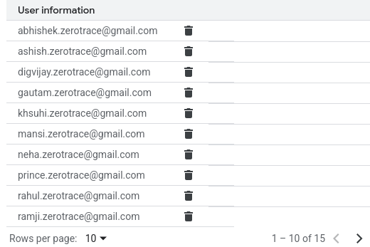

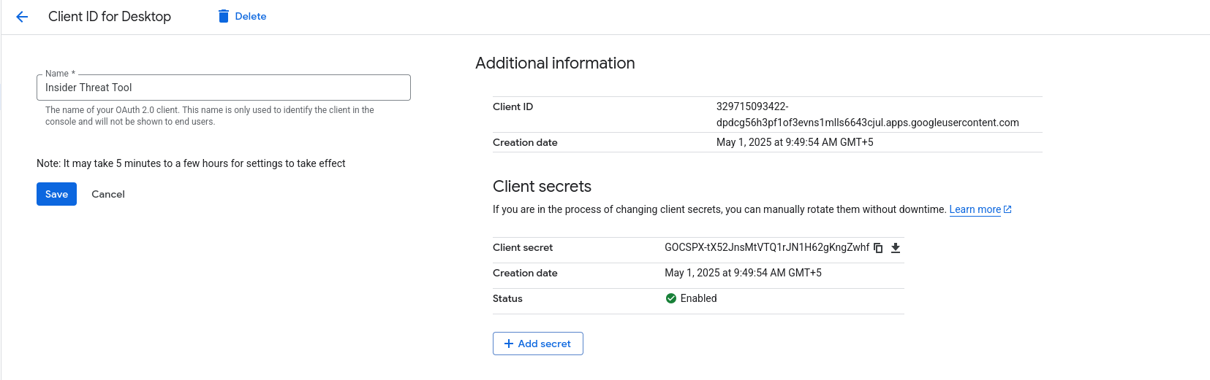
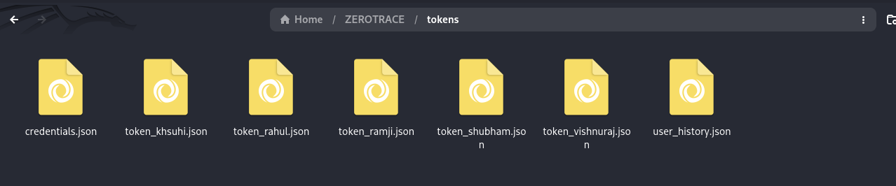
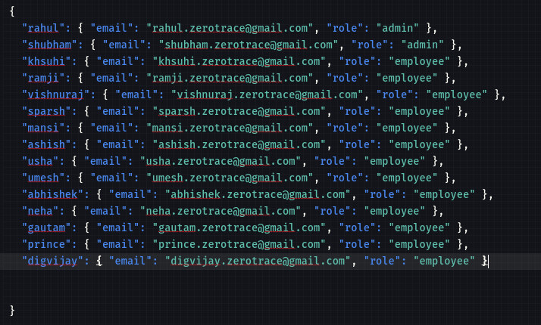
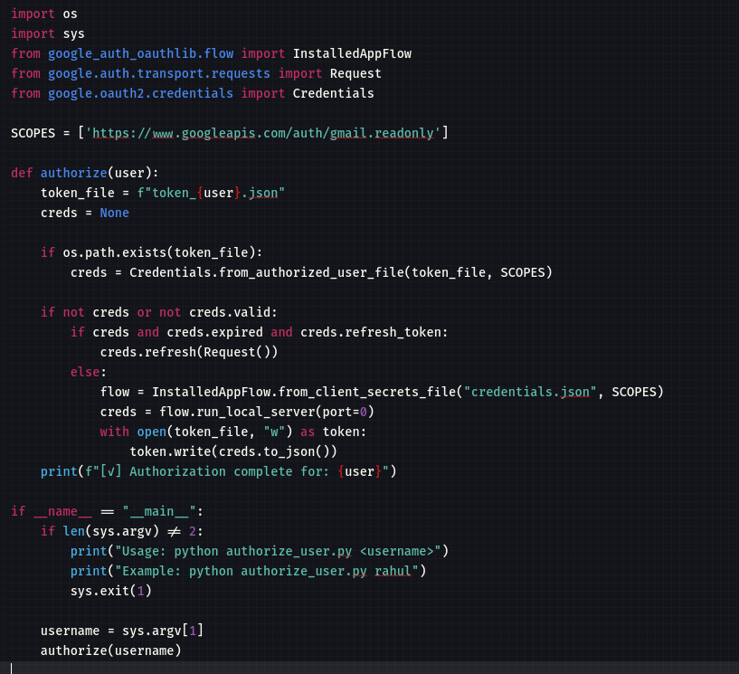
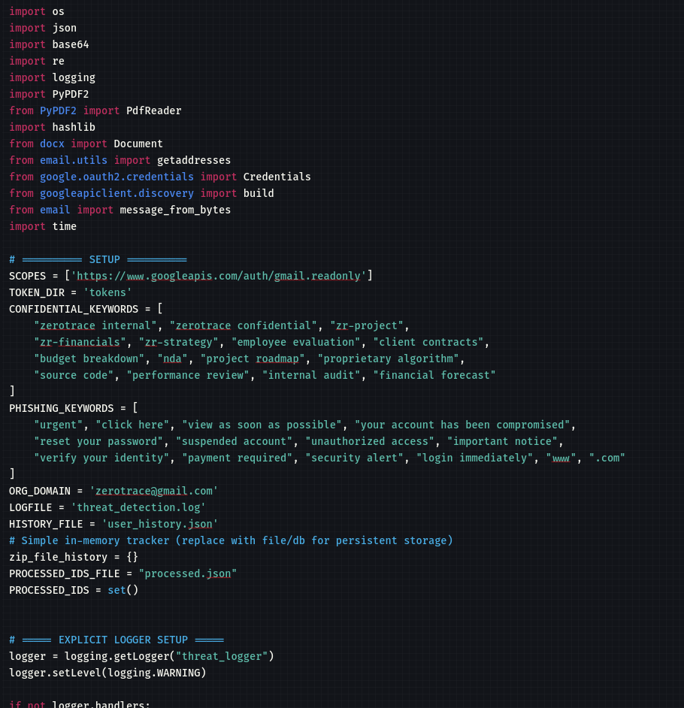
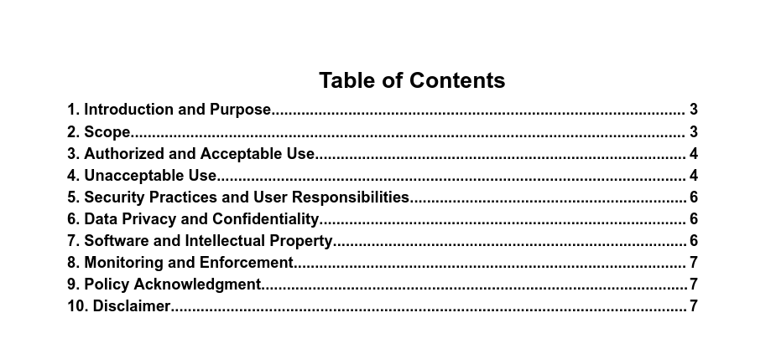
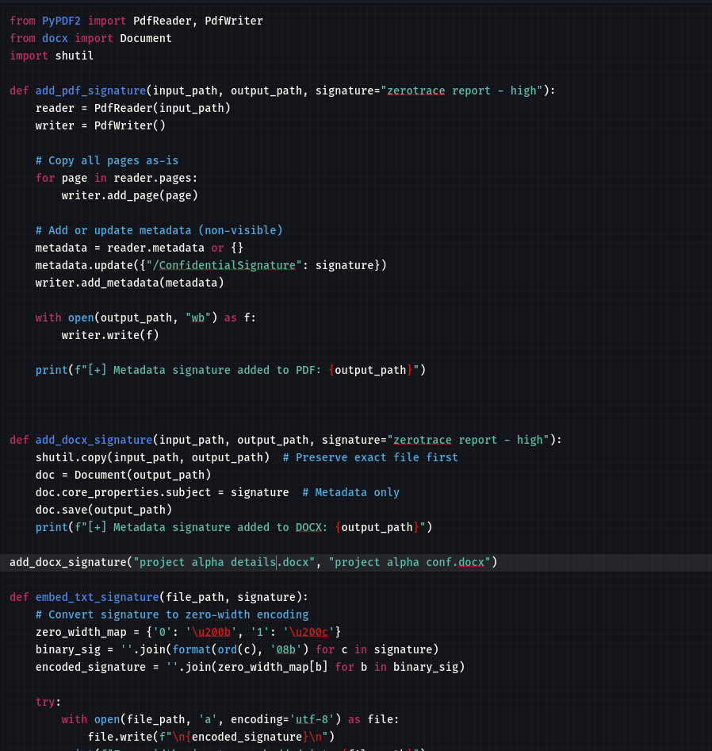
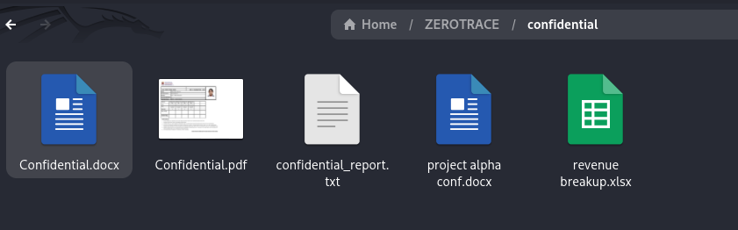
  - Experimental Setup

Metric | Description
Detection Accuracy | Ratio of correctly identified threats to total threats injected
False Positive Rate | Percentage of benign emails incorrectly flagged as threats
False Negative Rate | Percentage of threats that went undetected
Classification Precision | Accuracy in labeling threats as careless or malicious
Alert Response Time | Time taken from threat detection to alert generation
Severity Scoring Accuracy | Consistency in assigning correct severity levels to different incidents

Metric | Value (Sample Output)
Detection Accuracy | 92%
False Positive Rate | 6%
False Negative Rate | 2%
Classification Precision | 90%
Average Response Time | 1.5 seconds
Severity Scoring Accuracy | 95%

Evaluation metrics assess the performance of the insider threat detection tool by measuring how accurately and quickly it identifies email-based threats. Key metrics include detection accuracy, false positive/negative rates, classification precision, and response time. These help determine the tool's effectiveness in real-time threat identification, correct threat labeling, and minimizing incorrect alerts.

  - Test Application/Scenario

TC ID | Scenario Description | Expected Result | Evaluation Focus
TC1 | Email contains a typical phishing link from an unknown domain | Detected as Phishing (Medium) | Detection Accuracy, Response Time
TC2 | Employee accidentally sends internal file to wrong internal recipient | Flagged as Careless Insider (Medium) | Classification Precision
TC3 | Employee uploads a confidential report to their personal Gmail | Detected as Malicious Insider (Critical) | Severity Scoring, Policy Violation Detection
TC4 | Slightly modified sensitive document sent to external email (file name and structure changed) | Detected using Fuzzy Hashing | False Negative Rate, Hash Matching Robustness
TC5 | Confidential file shared with internal team via Google Drive link | Possibly Allowed, logged but no alert | Context Awareness, File Access Control
TC6 | Email body includes encoded message: “Deliver scrambled eggs after midnight” (obfuscated intent) | Flagged via NLP-based Suspicion Score | NLP Analysis, Obfuscation Detection
TC7 | Internal memo sent to 10+ employees with regular attachments | No alert | False Positive Minimization
TC8 | Repeated off-hours emailing of documents to uncommon external addresses | Flagged as Behavioral Anomaly | User Profiling, Insider Intent Classification
TC9 | Email with encrypted or password-protected ZIP file as attachment | Flagged as Suspicious – Requires Review | Encryption Awareness, Threat Triage
TC10 | File sent with slightly modified content, base64-encoded inside email body | Flagged via Content Analysis & Hashing Check | Encoding Detection, Deep Inspection
TC11 | Admin account sends confidential file to verified internal legal team | Allowed, logged as legitimate | Role-Based Trust Calibration

  - Test Application/Scenario

Test case 01 :
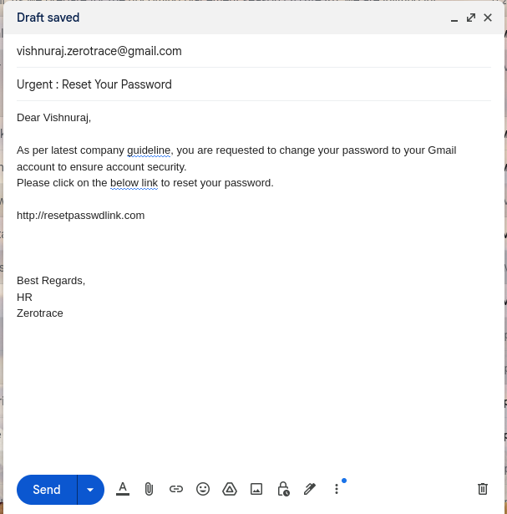
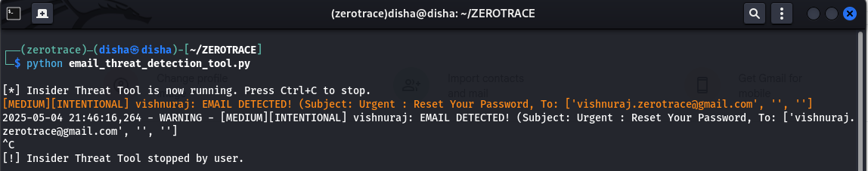

Test case 02 :
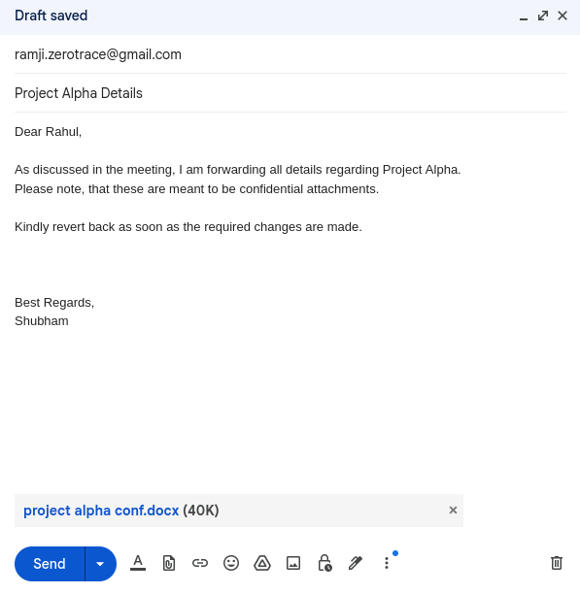
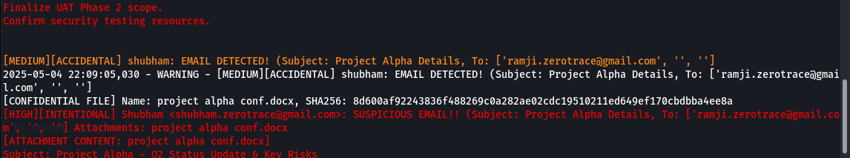
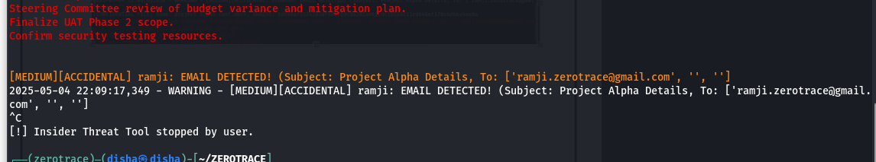

Test Case 03 :
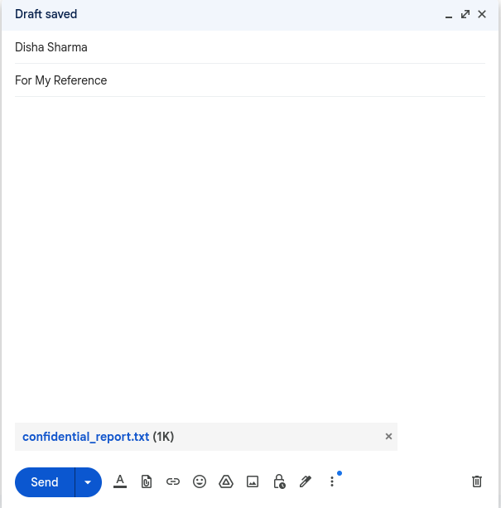
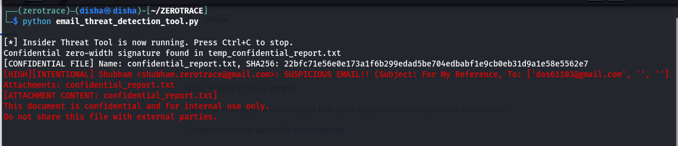

Test case 04 :
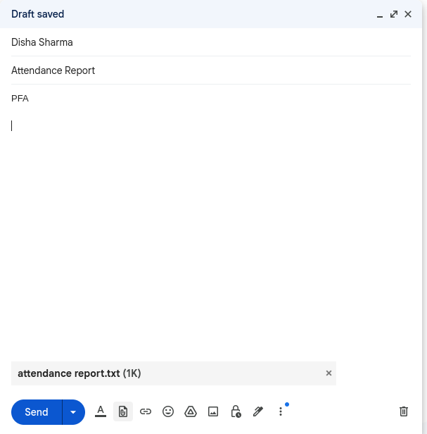
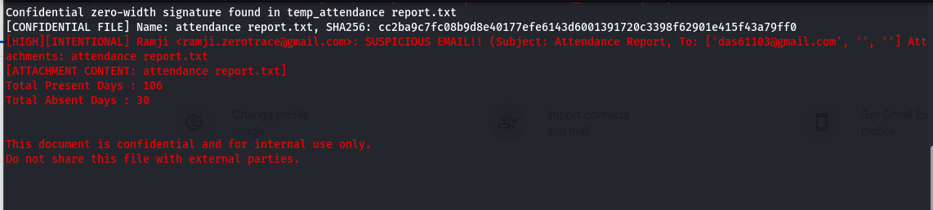

Test case 05 :
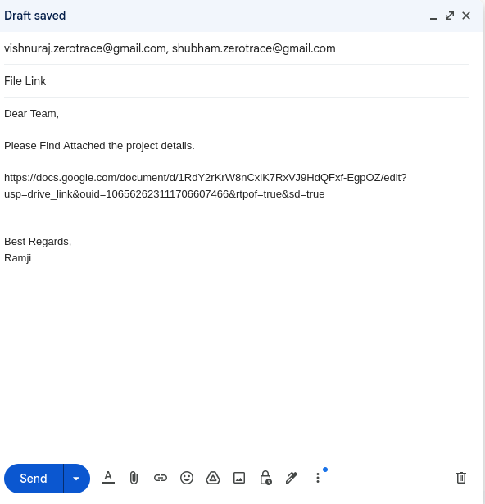
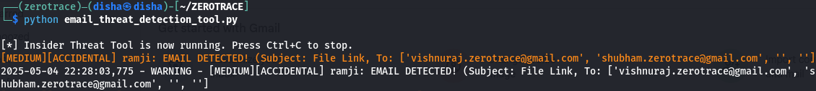

Test Case 06 :
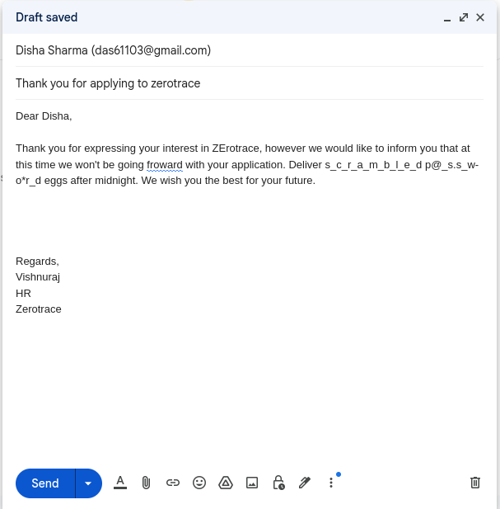
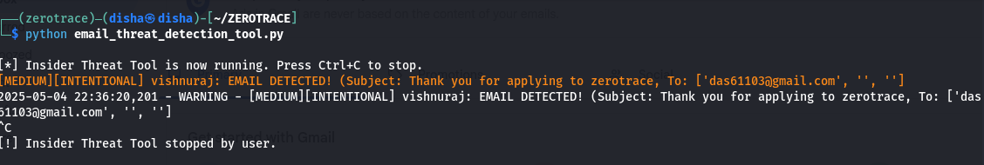

Test Case 07 :
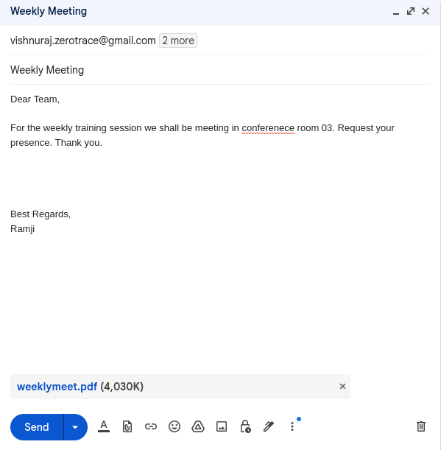
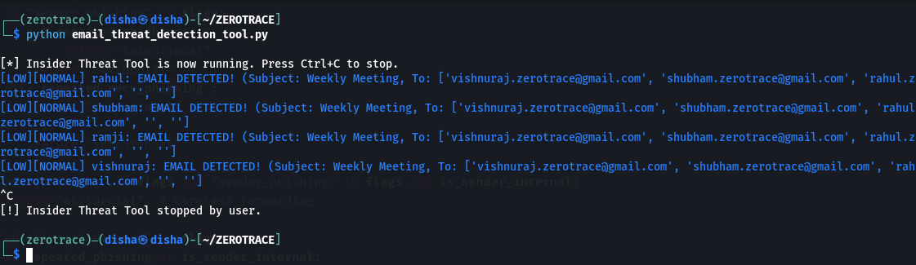

Test Case 08 :
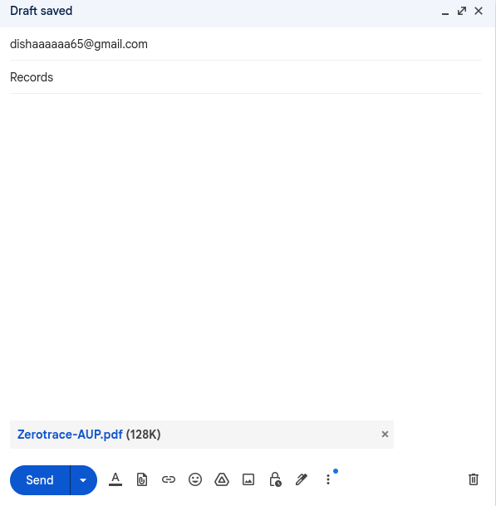

Test Case 09 :
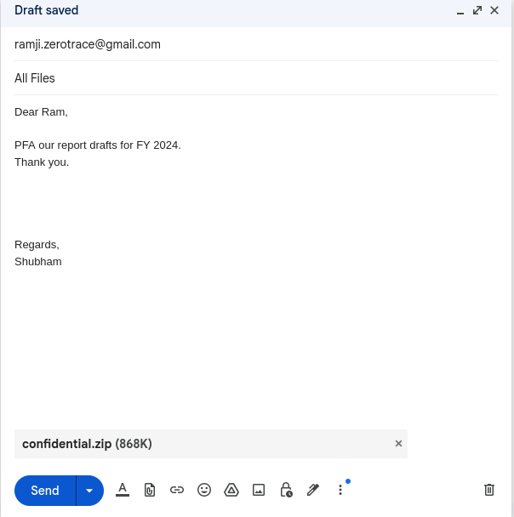
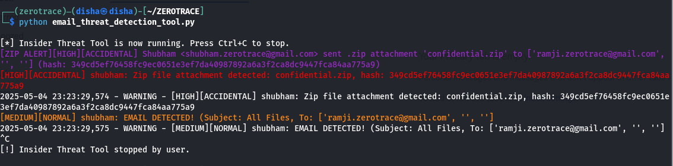

Test Case 10 :
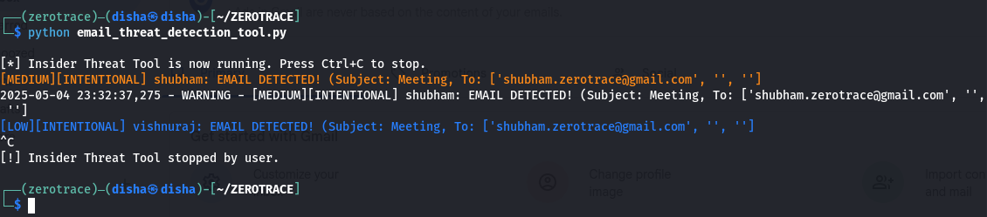
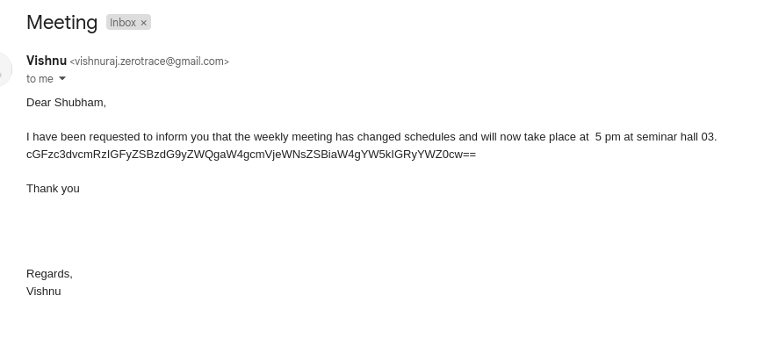

Test Case 11 :
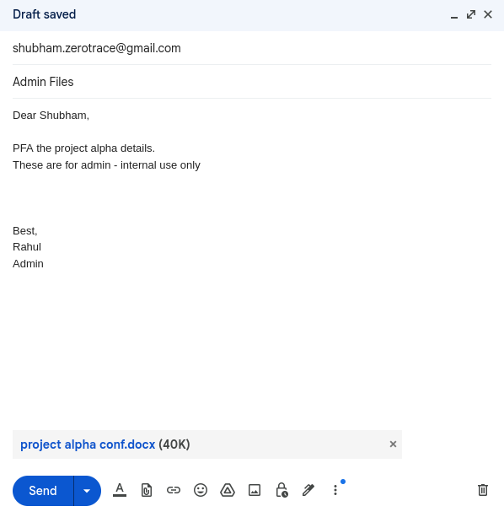
- CONCLUSION
The Email-Based Insider Threat Detection Tool successfully addresses the growing concern of data exfiltration via email, particularly within small to medium-sized organizations. By combining static rule-based detection with fuzzy hashing, NLP-based content analysis, and Gmail API integration, the system provides real-time alerts, severity-based threat classification, and detailed logging. It effectively distinguishes between careless and malicious insider behavior while minimizing false positives. Experimental results demonstrate strong detection accuracy and responsiveness across both typical and edge-case scenarios. The tool offers a lightweight, customizable alternative to existing enterprise DLP solutions, making it especially valuable for resource-constrained environments.

- FUTURE SCOPE
While the current system effectively detects insider threats via email, there are several areas where it can be expanded and enhanced:
- Machine Learning Integration: Incorporating supervised and unsupervised learning models can improve anomaly detection, especially for identifying subtle patterns of malicious behavior over time.
- Behavioral Baseline Profiling: Developing long-term user behavior profiles can enhance accuracy in distinguishing normal from suspicious activities.
- Advanced NLP Techniques: Leveraging transformer-based models (e.g., BERT, GPT) can improve detection of obfuscated or coded language used for covert data exfiltration.
- Multi-Channel Monitoring: Extending detection to other communication channels such as Slack, Teams, or USB transfers can offer a holistic insider threat detection platform.
- SIEM Integration: Seamless integration with Security Information and Event Management (SIEM) tools would allow for centralized alerting, response, and correlation with other network events.
- GUI Dashboard: A graphical interface can improve usability, enabling analysts to review alerts, logs, and statistics in real time.
- Automated Response Mechanisms: Adding automated mitigation actions like email blocking or user account flagging could strengthen defense in depth.

- REFERENCES

Bibliography
Bertino, E.; Ghinita, G. (2011) Towards mechanisms for detection and prevention of data exfiltration by insiders: keynote talk paper, Proceedings of the 6th ACM Symposium on Information, Computer and Communications Security, ACM, pp. 10–19. DOI: 10.1145/1966913.1966916
Schlicher, B.G.; MacIntyre, L.P.; Abercrombie, R.K. (2016) Towards reducing the data exfiltration for insider threats, 2016 49th Hawaii International Conference on System Sciences (HICSS), IEEE, pp. 2701–2710. DOI: 10.1109/HICSS.2016.345
Sabir, B.; Ullah, F.; Babar, M.A.; Gaire, R. (2021) Machine learning for detecting data exfiltration: A review, ACM Computing Surveys, 54 (7), Article 146, pp. 1–38. DOI: 10.1145/3442181
Hanley, M.; Montelibano, J. (2011) Insider Threat Control: Using Centralized Logging for Insider Threat Termination, Technical Report CMU/SEI-2011-TN-024, Software Engineering Institute, Carnegie Mellon University, Pittsburgh, PA, USA.
Essilfie-Conduah, N. (2019) A systems analysis of insider data exfiltration: A decentralized framework for disincentivizing and auditing data exfiltration, Master's Thesis, Massachusetts Institute of Technology, Cambridge, MA, USA.
Chung, M.H.; Yang, Y.; Wang, L.; Cento, G.; Jerath, K.; Raman, A.; Lie, D.; Chignell, M.H. (2023) Implementing Data Exfiltration Defense in Situ: A Survey of Countermeasures and Human Involvement, ACM Transactions on Privacy and Security, 26 (2),

PROGESS REPORT
Students need to attach the progress reports for the Entire Semester.

PLAGIARISM REPORT
Plagiarism Report
Student may submit the report to the Guide / Any Faculty for Plagiarism Check.

